North Lincolnshire Council
Daily Event Analysis
27th October 2010

Overview
The Low Santon TEOM measured a daily mean PM₁₀ concentration of 78µg/m³ on Wednesday 27th October 2010 exceeding the allowed 50µg/m³ as a daily mean. The Dawes Lane Coke Oven (DLCO) Osiris measured a daily PM₁₀ concentration of 48μg/m³. A check of the data has revealed that the PM₁₀ concentrations were significantly above the 50μg/m³ threshold between 12:00 and 17:00 at the Low Santon TEOM, the same period at the DLCO Osiris measured concentrations marginally above the daily objective limit. The average PM₁₀ concentration for this time period at the Low Santon TEOM was 194μg/m³. The DLCO Osiris averaged at 60μg/m³.

Met Conditions
Consistent SW winds were observed throughout the day. The wind within the 5 hour period of focus ranged between 224° and 253°. Wind speeds averaged at 3.7 m/s. No rain was measured throughout the day .

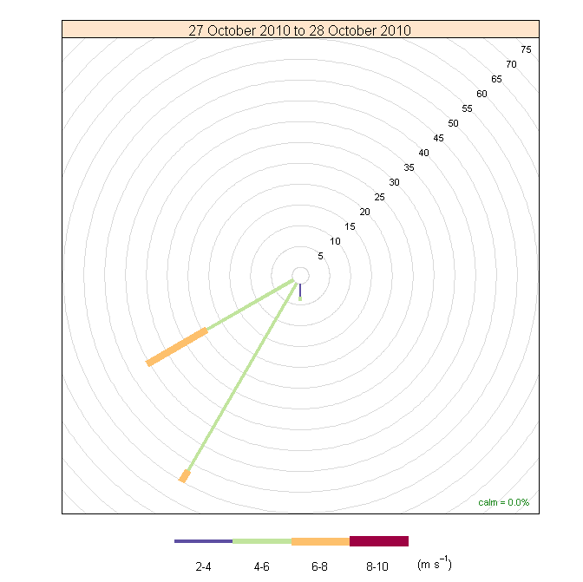

Episode Wind Range

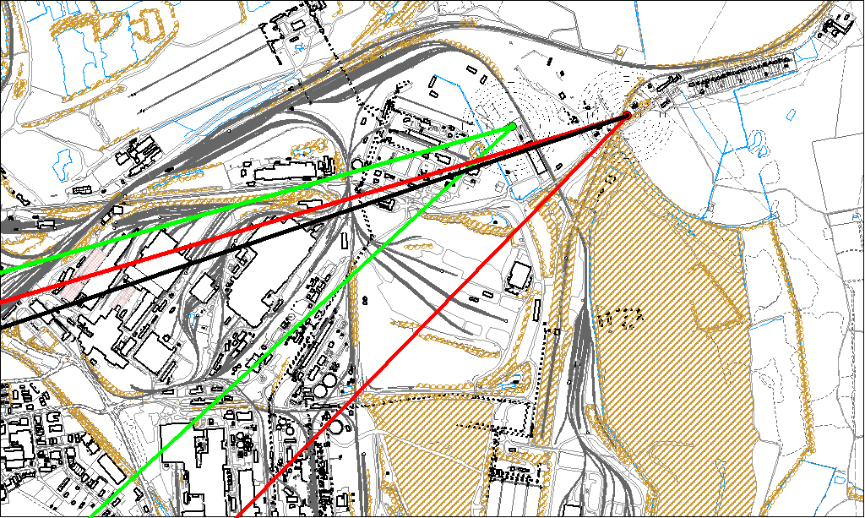

Potential Sources
The above map shows the Low Santon TEOM (indicated by the red lines) and the DLCO Osiris (indicated by the green). The black line within the red shows the wind direction of the highest concentration recorded during the 5 hour period of focus.

As the Low Santon TEOM measured consistently higher concentrations during this period, it is likely that the TEOM was affected by a different source to the DLCO Osiris. Because of this difference the areas in which the red and green lines intersect are unlikely to be the location of the problem.

The likely areas include;

- Tarmac
- Redbourn Site

The black line indicates the highest measured concentration of 361μg/m³ recorded at the Low Santon TEOM during this period. It runs through the Tarmac site and the Dawes Lane Coke Ovens.

